Back testing objective and requirement:
- Download historical data for nifty, sensex, bank nifty, finnifty using the Dhan historical API for last 1 - 2 years and store it locally for reuse to test the strategies and AI agents.
- Data stored locally should be maintained efficiently to easy access and fast retrival and maintained for 2 years. If needed, local free & open-sourced of database can be established.
- Define a separate agent for back testing.
- On daily basis, it should download the historical data of previous day & current day after 03: 45 PM to update the already available data for correction and current day new data.
- While creating the strategy, strategy must be testing for historical data for strategy effectiveness, profitability and loss estimation, % win rate, avg profit/avg loss, max profit/max loss, risk per trade. Max number of tested date, win loss ratio.
- Once a strategy or AI signal is fully testing with high confidence level then it should automatically deploy it (if auto mode selected), if case of manual mode, it should the win rate and max win and loss.
- If needed, it can perform minimum testing on run time to analysis the strategy.
- On the day end (post 03:45 PM), back-testing agent should revalidate the current the strategy outcome and revalidate it with respect to historical data, retune the strategy if its results are not as per expectation and loss per trade is more than 5% and its hits the SL or not able to achieve the Target 1 itself.
- Maintain the version of strategy for analysis and if new strategy is not working it should roll back to previous version either manually or automatically.
- Revised strategy should also be revalidated for historical data and deploy it if results are improved compared to previous version.
- It should log the reason of revision in strategy with impacted parameters and revised parameters and also publish on strategy dashboard for the new version.
- On strategy portal or dashboard, it should have separate tabs for strategy results, strategy configuration version wise and test results for analysis in interactive ways with proper colour coding and charts if needed.
- Visualisation is must.
Since today is Sunday, can we utilise it to prepare this agent?
Deployed
New comments (19 Jul 2026 02:30 PM)
- Agents should run in backend automatically, UI should only shows it status. Also, buttons should remain there to re-run the agent and to stop all agents.
- Historical data downloaded –
NIFTY0 chain days · 1,92,632 idx candles (757d)
SENSEX0 chain days · 1,92,890 idx candles (757d)
BANKNIFTY0 chain days · 1,92,632 idx candles (757d)
FINNIFTY0 chain days · 1,92,632 idx candles (757d)
- After clicking on “Run Backtest” , it waits for backtest agant but backtest agent respond with message - [2026-07-19 14:30:46] [backtest] no archived chain days yet — archive builds daily from close
- Also on price chart, PM is repeating again and again –

- NIFTY 5m · @ 2:31:35 pm pm pm pm pm pm pm pm pm pm pm pm pm pm pm pm pm

Intraday Strategy
Opening range breakout (5 mins ORB with VWAP filter
VWAP pullback (trend Following)
9/20 EMA crossover with Multi-Timeframe Confirmation
Strategy and Backtest dashboard: (19 Jul 21:00)
- Bull_put_spread, bear_call_spread version and backtest results are not available.
- For ORB, vwap_pullback, ema_mtf configuration should be available on separate pop up pages in readable format, for current and previous version to check what are indicator/inputs defined with parameters, entry and exist criteria in a tabular format. So, if I click on a version, it should show the configuration, version, active status (Live, Paused, blocked etc), also, option should be available to disable or manually activate a strategy (even the older version).
- Since, strategy are adaptive so for each version, changes should be highlighted.
Observations: (19 Jul 22:45 PM)
- "click for details" option on version card is not working on selected strategy. it is not opening any configuration and back-testing results page.
- Back-testing graph should be shown within the result row in the last column rather than separately. To analysis the graph it should be popped up and scrollable.
- Nifty vwap pullback revised results are more on negative side.
- Back testing execution time is not mentioned on the version.
- Once a daily Journal is prepared, it should be available on portal in readable format to understand the day wise outcome.
- It is not clear how much capital and margin has been used for testing. It should be configurable in setting for back -testing and same can be used for placing order automatically. If it requires separate parameters then make it configurable accordingly.
Status: deployed

Date | Observations | Status | Deployed?
20 Jul 2026 | Regression testing:  Perform regression testing of strategies and AI trade signal execution for worst case scenarios. Considered capital of around 10,00,000 with 100% margin. Consider 50, 100 points, 200 points, 500 points drop in single 1 min candle. What are the other possible scenarios for regression testing of our strategy? | Included | YES
 | Change the layout of LIVE or Paused strategies on Backtest page. Rather than row for each card, change layout to 5 cards in one row.
20 Jul 2026 | Add Backword APIs for real time market execution
20 Jul 2026 | Build Current position and Order status dashboard
20 Jul 2026 | On Strategy page, there should be 2 strategy cards in a row. | Included | YES
20 Jul 2026 | Button on each page should be of different colour rather than of white or black, so that it can be easily visible. | Included | YES
 | Don’t use Purple colours for all button, use colour different from base colour, that was the expectation. | done
 | Choose button colour other than Purple and also not much bold colur.
 | News Agent should validate the news with respect to risk and opportunity and accordingly block the trades or allow trade
 | Setting page now have lots of configuration and most of them are scattered. Club similar settings and parameters and utilities the whole page using 2x2 or 2x3 column structure.
 | Validate the Regression and stress test results and confirm whether this results are acceptable and does system need any improvement
 | Daily Journal : there should be options to select the date and load the journal for that date rather than showing everything on single page.  Same for shade signal journal. Also, wherever parameters and values mentioned there should be some space between them for example:  Total signals16  Approved1  Rejected15  Rejections resolved15  Would have WON0 (rejection cost a win)  Would have LOST5 (rejection was correct)  Risk agent accuracy33.3%  Same on backtest & validation page |  | Done
 | In the log, include the entry price, SL, t1, t2 along with signal to do further analysis |  | Done
 | In order history and all other table where only time is used, add date along with time.  Add filter by date, rather than showing all the records. This testing will continue long so it should not avoid long log list. |  | Done
 | Observations based on last order history:  1.**Eliminate discretionary manual exits** by replacing them with rule-based exits.  2. **Reduce target distances** to realistic intraday option moves (e.g., 20–40%) and trail the stop after the first target.  3. **Implement spread defence rules** when the short strike is approached or breached.  4. **Track MAE (Maximum Adverse Excursion) and MFE (Maximum Favourable Excursion) ** for every trade. This will reveal whether trades are being exited too early or held too long.  5. **Build a trade quality dashboard** showing expectancy, win rate by hour, win rate by setup type, filter effectiveness, and exit efficiency. These metrics will tell you whether the edge lies in entries, exits, or specific market conditions.  6. keep stoploss 2% of total capital and decide lot size based on available margin, ongoing order & spreads. Choose optimal. |  | Done
 | Solar harmonic Pulse (barmesh) |  | NA
 | Gann Scanner – intraday Gann trade levels |  | NA
 | Time stop loss |  | Done
 | Modify layout similar to website https://supabase.com/docs, uniform colours tone, fonts, better icons, side menu, structured page view.  https://supabase.com/design-system/docs/color-usage | Add appropriate icons for each page in the menu. | Done
 | For each trade and spread execution, add capital/margin used. Also, on top show - total capital, capital used, capital remaining and current day P&L including spread. |  | Done
 | Fundamental - Global stock market impact – DJI, NESDAQ, JAPAN – NIKKI, China, News – IT, pharma, Auto, banking sector, reliance and Adani, solar, renewable, semi-conductor. Global market review during off market hours.  FDI and NIFTY, crude oil, |  | Done

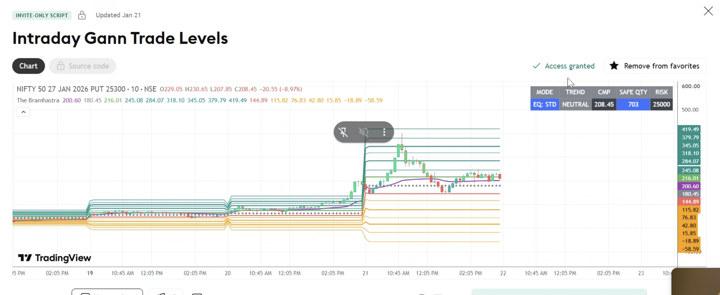

Roadmap
- Margin-aware position sizing — current dynamic sizing looks at total capital per-trade, but not what's already deployed across open positions/spreads. Should size against remaining capital, not gross capital.
- Spread defence rules — act when the short strike is approached, not only when it's breached (rolling, tightening, or early partial exit).
- MAE/MFE tracking per trade — needed groundwork before the trade-quality dashboard makes sense.
- Reduce target distances to realistic 20-40% moves + trail stop after T1 — a concrete parameter-tuning pass across the strategy library.
- Journal + Shadow Journal: date picker and real filtering instead of dumping everything on one page — you're right that long-running testing will make this unusable otherwise.
- Chart.js visual pass / TradingView Lightweight Charts
- ML scoring (once shadow journal has volume — it's now collecting)
Real, larger features (each is its own solid session):
- News agent — risk/opportunity scoring instead of a blanket block window.
- Trade quality dashboard — expectancy, win rate by hour/setup, exit efficiency (depends on #3 existing first).
- Settings page reorganization into a grouped, columned layout.
- Liquidity-sweep / FVG confluence layered onto the OI-wall logic.
- ML probability scoring — shadow journal is accumulating real volume now, getting closer to viable.
- Full visual redesign (Supabase-docs style) — biggest single item, essentially a frontend pass across the whole app. For colour usage refer this link: https://supabase.com/design-system/docs/color-usage
Blocked on your input — I don't want to guess and build the wrong thing:
12. Solar Harmonic Pulse (Barmesh) — still need a description or reference for this one.
13. Gann Scanner — need to know which specific method (Square of 9, angles from a pivot, time cycles).

Pending roadmap items (not yet started):
# | Item
6 | Chart.js visual pass / TradingView Lightweight Charts
7 | ML scoring (shadow journal is accumulating volume now)
9 | Trade quality dashboard — expectancy, win rate by hour/setup, exit efficiency | Done
11 | Liquidity-sweep / FVG confluence layered onto OI-wall logic
12 | ML probability scoring (same track as #7, larger scope)
13 (partial) | Full visual redesign — token/color/icon/settings/journal-filter pass done this session and last; charts, dashboard/P&L/Strategies/Backtest/Agents panel emoji cleanup, and deeper Supabase layout patterns (breadcrumbs, page sections elsewhere) still open | Done
On the candle chart, show the entry and exit point based on the 1. Swing Detection 2. Trend Detection 3. Trendline Detection 4. BOS Detection 5. CHoCH Detection 6. Support Resistance 7. Supply Demand 8. Liquidity Sweep 9. Fair Value Gap 10. Premium Discount Zones, superband, HH/HL/LH/LL, BOS, CHoCH, HVN/LVN, POC, OI, PCR, Max Pain, IV, Intraday bias and tune
ALGORITHMS
• Ramer–Douglas–Peucker
• Hough Transform
• ZigZag-based trendlines
 | Revalidate and tune the AI engine and its efficiency based on set parameter, additional information can be provided if needed.
Integration with Tradingview lite library for creating the chart (nifty, sensex, finnifty, bank nifty), show analysis indicators (average price, median price, simple moving average, spread, sum, weighted close, %change, momentum, correlation, product, ratio), use tradingview capabilities.
Take input from the chart for analysis using separate agent (if needed) for picking entry and exit points.

https://tradingview.github.io/lightweight-charts/docs/api
https://github.com/tradingview/lightweight-charts

Dhan also provide Phyton library
Websocket for live stream;
https://github.com/dhan-oss/DhanHQ-js

it also support skills
https://github.com/dhan-oss/dhanhq-skills

Ai youtube channels: Sabina ramonov, ben a, jeff su, liam ottley, dan martell
Python for AI – daveebbelaar
fastAPI -

You're working on the ltp-monitor project — a multi-agent Indian options trading terminal (NIFTY/BANKNIFTY/FINNIFTY/SENSEX), currently running in paper mode with live Dhan integration. TASK: Open ROADMAP.md and pick exactly ONE pending item to implement this session. Do not attempt multiple items. Read the relevant sections of ROADMAP.md fully before starting — several items reference specific prior bugs/decisions you need context on. Candidates, in suggested priority order (skip any that turn out already done, or that fall into the exclusions below):

1. Futures OI flowing live into the MTF Confluence strategy — the data plumbing already exists (dhan_ws.py's add_future_instrument(), dhan_scrip_master.py), and the strategy already reads the bus key it needs (future_oi_trend:{symbol}, currently always empty/None). This is wiring MarketDataAgent's hybrid loop to also subscribe the current-month future per symbol and classify long/short buildup onto that key — a well-scoped, mostly-plumbing task.

2. #11 — Liquidity-sweep / FVG confluence layered onto the OI-wall logic.

3. The DJI/Nasdaq/Crude/Gold/Silver/macro-event SUMMARY view — the underlying data already exists in NewsMacroAgent; this is adding a genuine digest view to the Macro/News page, not new data plumbing.

4. #6 — Chart.js visual pass / TradingView Lightweight Charts for existing dashboard panels (unrelated to the TradingView licensing item — see exclusions below).

5. #7/#12 — ML probability scoring, only if the shadow journal has accumulated enough volume to make this viable — check first.

- The full second Pine Script from rinkoo.docx (pivot-based MACD/ RSI/Stochastic divergence detection, EMA 1H cross with weekly/ daily context, Fibonacci-extension targets, live confluence table). This is a substantially larger effort than every other item here — only pick this if you have a genuinely long session available, and if you do, treat it as its own multi-part build with the same testing rigor as the first MTF Confluence strategy (mtf_confluence_strategy.py), not a rushed port.

- The Avadhut Sathe Triple Screen / 3rd Wave checklists — saved for reference, not scoped as strategies yet

SPECIAL HANDLING — do not just "implement" these two: - "News as an active decision input beyond block/pass" — this is explicitly flagged as needing a DESIGN DECISION before code (how much should a severe news event actually move an entry/exit decision, and how is severity scored). If you pick this, your deliverable is a written design proposal in ROADMAP.md — options considered, a recommendation, open questions for the user — NOT an implementation. Do not write code for this one without that sign-off step happening first. - Avadhut Sathe Triple Screen / 3rd Wave Setup checklists — these are saved reference material (docs/strategy-reference/), not scoped as strategies. Do NOT attempt to implement either as a trading strategy. If you want to work on these, the deliverable is a scoping writeup (what a Triple Screen or 3rd Wave strategy module would need, what's genuinely buildable vs. requires chart-pattern recognition beyond this project's current capability) — not code. EXCLUDE from consideration entirely: - TradingView integration — blocked on a licensing decision the user will make separately. Do not build a substitute (e.g. a native chart standing in for "TradingView integration") — that would misrepresent what was actually delivered. Leave untouched. HARD RULES: - Do NOT modify anything in the execution/risk path (ExecutionAgent's place()/exit()/exit_spread(), RiskAgent.evaluate(), sizing.py, position/spread entry or exit logic) as part of this task, even incidentally, unless the chosen item specifically requires it. If it does, stop and produce a written diff/plan instead of applying it directly — do not push execution-path changes live unattended. - For anything you DO change: write and run actual tests before declaring it done. Use synthetic data engineered to hit edge cases, not just the happy path — this project's prior sessions found real bugs (an unclamped ATR stop, a silent connection-timing race, contradictory roadmap entries) precisely because of adversarial testing, not optimistic testing. - Run the existing regression pattern before finishing: `python3 -c "import ast; ast.parse(open(f).read())"` across every touched Python file, JS syntax validation on dashboard.html if touched (extract the largest <script> block, run `node -c`), and a FastAPI TestClient smoke test hitting the key endpoints (/, /api/quality, /api/macro, /api/journal, /api/autopilot/status, /api/strategies/NIFTY). - Update ROADMAP.md when done: mark the item complete (or, for the two special-handling items, mark the design/scoping doc as delivered), describe what was actually built and tested, and note anything deliberately deferred rather than silently dropped. - Do not touch config defaults for anything outside the item you picked. - If dashboard.html is touched, verify `wc -c static/dashboard.html` stays above 30,000 bytes before considering the task done. Leave a clear written summary at the end: what you picked, why, what you built (or proposed, for the design-decision items), how you tested it, and what — if anything — needs my review before it's trusted, especially anything touching live paper trading.

You're working on the ltp-monitor project — a multi-agent Indian options trading terminal (NIFTY/BANKNIFTY/FINNIFTY/SENSEX), currently running in paper mode with live Dhan integration. TASK: Implement below functionalities and prepare the updated package: Futures OI flowing live into the MTF Confluence strategy — the data plumbing already exists (dhan_ws.py's add_future_instrument(), dhan_scrip_master.py), and the strategy already reads the bus key it needs (future_oi_trend:{symbol}, currently always empty/None). This is wiring MarketDataAgent's hybrid loop to also subscribe the current-month future per symbol and classify long/short buildup onto that key — a well-scoped, mostly-plumbing task. HARD RULES: - Do NOT modify anything in the execution/risk path (ExecutionAgent's place()/exit()/exit_spread(), RiskAgent.evaluate(), sizing.py, position/spread entry or exit logic) as part of this task, even incidentally, unless the chosen item specifically requires it. If it does, stop and produce a written diff/plan instead of applying it directly — do not push execution-path changes live unattended. - For anything you DO change: write and run actual tests before declaring it done. Use synthetic data engineered to hit edge cases, not just the happy path — this project's prior sessions found real bugs (an unclamped ATR stop, a silent connection-timing race, contradictory roadmap entries) precisely because of adversarial testing, not optimistic testing. - Run the existing regression pattern before finishing: `python3 -c "import ast; ast.parse(open(f).read())"` across every touched Python file, JS syntax validation on dashboard.html if touched (extract the largest <script> block, run `node -c`), and a FastAPI TestClient smoke test hitting the key endpoints (/, /api/quality, /api/macro, /api/journal, /api/autopilot/status, /api/strategies/NIFTY). - Update ROADMAP.md when done: mark the item complete (or, for the two special-handling items, mark the design/scoping doc as delivered), describe what was actually built and tested, and note anything deliberately deferred rather than silently dropped. - Do not touch config defaults for anything outside the item you picked. - If dashboard.html is touched, verify `wc -c static/dashboard.html` stays above 30,000 bytes before considering the task done. Leave a clear written summary at the end: what you picked, why, what you built (or proposed, for the design-decision items), how you tested it, and what — if anything — needs my review before it's trusted, especially anything touching live paper trading.

For news utilities RSS feeds for real time news feeds, categorise the news (geopolitical, market, tech, business, economics, energy, mergers, banking, auto-sector etc), filter the news (use relevant news), analysis the news for market impact (Bullish, Bearish or neutral) and check will it impact the next candle in short 1 mins, 5 mins and 15 mins. Windows, feed the input to trade analysis agent.
Provide an interface where each news can be tracker with source, news discerption, market impact indicator, category, impact, action & valid or not?
Provide an option to Add or Delete and test the RSS feed source – including source name, url, category, region, ID; on the same page.

[2026-07-24 11:44:15] [execution] BANKNIFTY bear_call_spread: eligible but entry failed — bear_call_spread already open on BANKNIFTY at 57000
[2026-07-24 11:43:35] [news_macro] USDINR: primary providers failed (AV: We have detected your API key as QRZ7XMPZUPF2G9CE and our standard API rate limit is 25 requests per day. Please subscribe to any of the premium plans at https:; TD: USDINR not in TWELVEDATA_SYMBOLS mapping) — used yfinance fallback
[2026-07-24 11:43:34] [news_macro] SILVER: primary providers failed (AV: Thank you for using Alpha Vantage! Please consider spreading out your free API requests more sparingly (1 request per second). You may subscribe to any of the p; TD: SILVER not in TWELVEDATA_SYMBOLS mapping) — used yfinance fallback
[2026-07-24 11:43:33] [news_macro] GOLD: primary providers failed (AV: We have detected your API key as QRZ7XMPZUPF2G9CE and our standard API rate limit is 25 requests per day. Please subscribe to any of the premium plans at https:; TD: GOLD not in TWELVEDATA_SYMBOLS mapping) — used yfinance fallback
[2026-07-24 11:43:31] [news_macro] NIKKEI: primary providers failed (TD: HTTPError: HTTP Error 404: Not Found; AV: symbol not mapped to a commodity/FX function) — used yfinance fallback
[2026-07-24 11:43:30] [news_macro] RUSSELL2000: primary providers failed (TD: HTTPError: HTTP Error 404: Not Found; AV: symbol not mapped to a commodity/FX function) — used yfinance fallback
[2026-07-24 11:43:29] [news_macro] SPX: primary providers failed (TD: HTTPError: HTTP Error 404: Not Found; AV: symbol not mapped to a commodity/FX function) — used yfinance fallback
[2026-07-24 11:43:28] [news_macro] NASDAQ: primary providers failed (TD: HTTPError: HTTP Error 404: Not Found; AV: symbol not mapped to a commodity/FX function) — used yfinance fallback
[2026-07-24 11:43:28] [news_macro] DJI: primary providers failed (TD: HTTPError: HTTP Error 404: Not Found; AV: symbol not mapped to a commodity/FX function) — used yfinance fallback
[2026-07-24 11:43:27] [news] ⚠ feed fetch failed: The Financial Express — HTTP Error 410: Gone
[2026-07-24 11:43:23] [market_data] no current future found for SENSEX: {'error': 'no unexpired FUTIDX contract found for SENSEX (BSE) — check the CSV actually contains BSE derivatives rows', 'stage_counts': {'exch_matches': 70149, 'instrument_matches': 12, 'symbol_matches': 0}, 'likely_cause': "12 FUTIDX rows found on 'BSE' but none had underlying_symbol=='SENSEX' — sample underlying_symbol values seen: ['BITFUT', 'BKXFUT', 'BSXFUT', 'SX50FUT']"}
[2026-07-24 11:43:23] [market_data] no current future found for FINNIFTY: {'error': 'no unexpired FUTIDX contract found for FINNIFTY (NSE) — check the CSV actually contains NSE derivatives rows', 'stage_counts': {'exch_matches': 133656, 'instrument_matches': 15, 'symbol_matches': 0}, 'likely_cause': "15 FUTIDX rows found on 'NSE' but none had underlying_symbol=='FINNIFTY' — sample underlying_symbol values seen: ['']"}
[2026-07-24 11:43:22] [market_data] no current future found for BANKNIFTY: {'error': 'no unexpired FUTIDX contract found for BANKNIFTY (NSE) — check the CSV actually contains NSE derivatives rows', 'stage_counts': {'exch_matches': 133656, 'instrument_matches': 15, 'symbol_matches': 0}, 'likely_cause': "15 FUTIDX rows found on 'NSE' but none had underlying_symbol=='BANKNIFTY' — sample underlying_symbol values seen: ['']"}
[2026-07-24 11:43:21] [market_data] ws: connected — 4 instrument(s) subscribed
[2026-07-24 11:43:20] [market_data] no current future found for NIFTY: {'error': 'no unexpired FUTIDX contract found for NIFTY (NSE) — check the CSV actually contains NSE derivatives rows', 'stage_counts': {'exch_matches': 133656, 'instrument_matches': 15, 'symbol_matches': 0}, 'likely_cause': "15 FUTIDX rows found on 'NSE' but none had underlying_symbol=='NIFTY' — sample underlying_symbol values seen: ['']"}
[2026-07-24 11:43:19] [market_data] websocket market-data feed started (hybrid mode: REST for chain shape/greeks, websocket overlay for live LTP/OI/spot)
[2026-07-24 11:43:14] [execution] no spreads deployed this cycle — {'no_analysis': 8, 'on_cooldown': 0, 'not_eligible': 0, 'max_concurrent': 0, 'entry_failed': 0}. no eligibility data yet
[2026-07-24 11:43:14] [price_action] no PA signals this cycle — {'no_position_free': 0, 'stale_or_missing_pack': 4, 'no_analysis': 0, 'on_cooldown': 0, 'no_setup': 0} (no-setup by strategy: {'orb': 0, 'vwap_pullback': 0, 'ema_mtf': 0})
[2026-07-24 11:43:14] [orchestrator] all 14 agents started on NIFTY+BANKNIFTY+FINNIFTY+SENSEX (PAPER)
[2026-07-24 11:43:11] [orchestrator] restored 0 open position(s) and 6 open spread(s) from before restart — re-validating live prices on next cycle
[2026-07-24 11:43:11] [orchestrator] restored 92 historical trades (16 today, ₹5087 realized today)

Most of the strategy either failed during the entry or exit and unable to take decision at right time which leads to the loss per trade. Initially during the morning team, it was making profit when market was volatile but later it was failed to analyse the market movement and adopt right strategy to make objective. NOTE THAT, OVERALL OBJECTIVE OF THIS APPLICATION IS TO MAKE PROFIT USING THIS ALGO. So, reanalysis the strategy checkpoint, retune it, verify it using online information (best suited).
On NEWS tracker – there are more than 500 news feeds, it would be better to reanalysis the feeds to check for suitability of execution and to use it to analysis market sentiment, market impact and chain impact. Also, all 500 news feeds are available on same page, the ‘NEWS tracker’ zone should have defined height for max 15 news, user can scroll down for more news. Add creation time of the news (high to low). News feeds should be fade off after 2 market days.
In the digest section, there is no summary output.
GLOBAL Market snapshot, are just a number, it can be used.

Still on the backtest page-
SENSEX 0 chain days · 1,94,020 idx candles (763d), chain count is 0.

On P&L Page:
‘order history’ section, define the height for 20 records and rest for scroll.
“day wise P&L” section, define the height for 5 records and rest for scroll.
When a position is open, it is not available in ‘open position’ section

Strategy:
What is needed to enable “MACD+Stoch Confluence” strategy?
Strategy deep analysis and retuning required. Market moved up and down multiple time and with the capital of 10,00,000 INR it is making hardly 10-1000 per trade and waiting for more than 1 hours for next moves. It is picking spreads where loss projection is higher compare to profits.
Strategy should focus on Future derivatives, perform analysis and pick trades.

Include tradingview for analysis and provide strategy on it. Paid version is available.

For deep analysis use langGraph

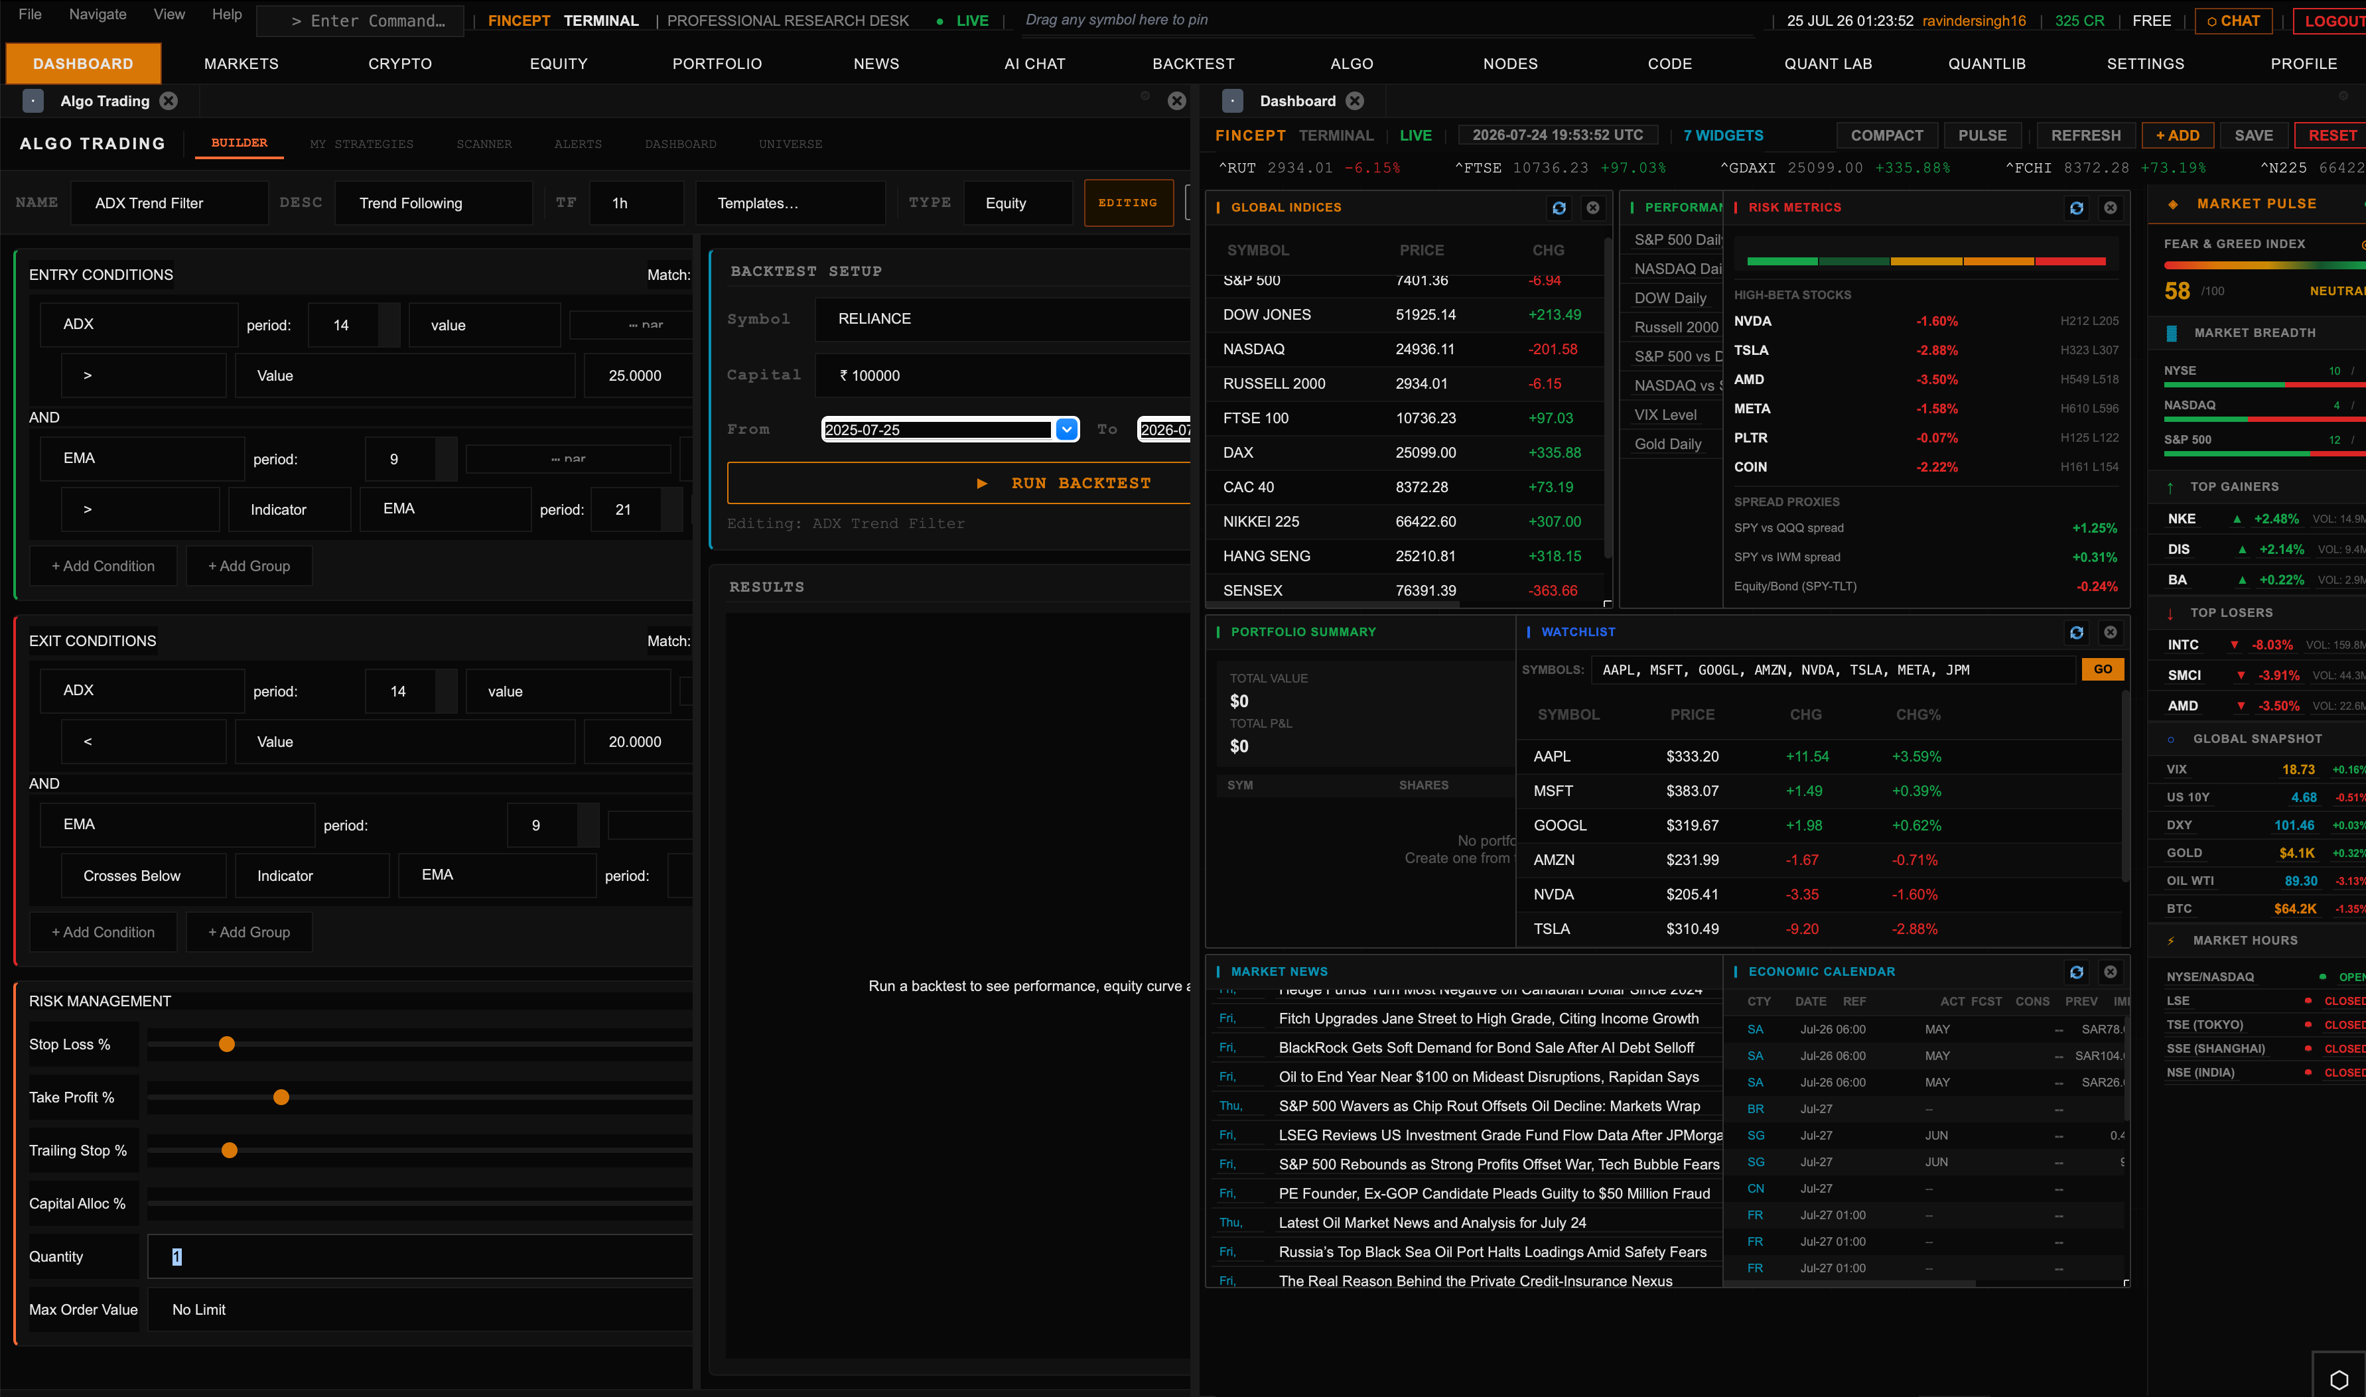
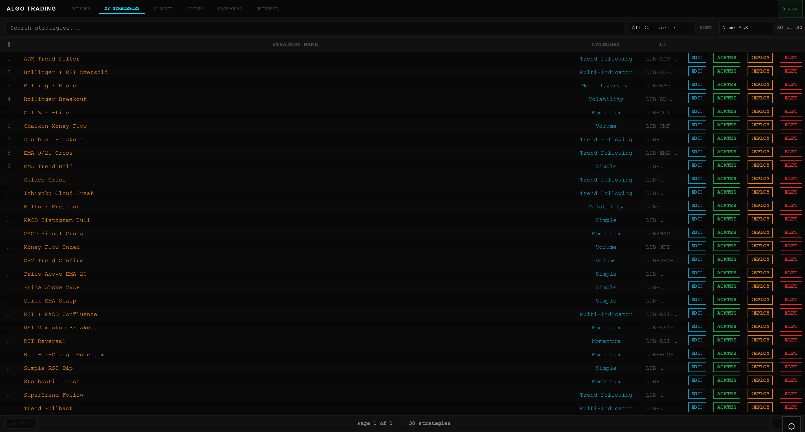
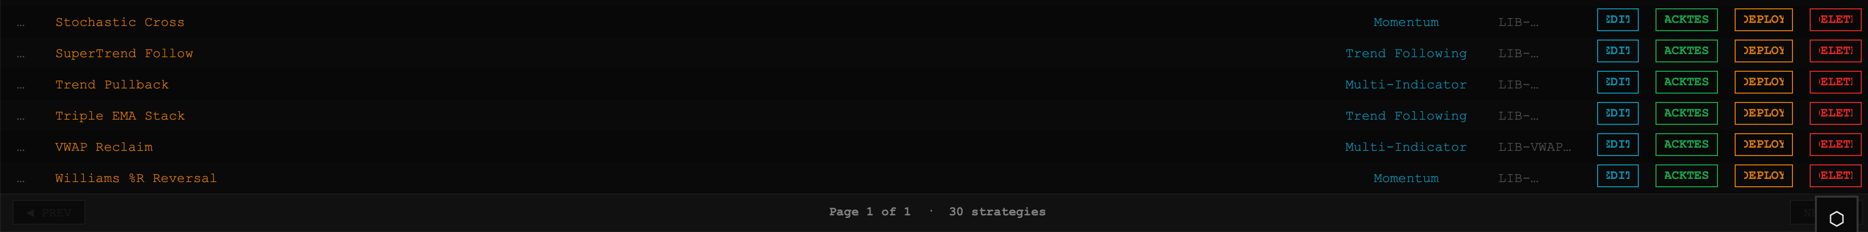

You are now working as quant engineer, enhancing an existing AI-based Intraday Trading application. Do NOT rebuild the project. Reuse all existing architecture, APIs, TradingView integration, Dhan APIs, WebSocket services, Option Chain module, Strategy Engine and database. Extend existing modules only.

Goal:
Convert the existing LTP Monitor into an Institutional Grade AI Options Trading Dashboard.

========================
1. LTP MONITOR
========================

Enhance the monitor for:

• NIFTY
• BANKNIFTY
• FINNIFTY
• SENSEX

Display in real time:

- Spot LTP
- Futures LTP
- Spot %
- Futures %
- Open
- High
- Low
- VWAP
- Previous Close
- Live Tick
For each index, the application should simultaneously monitor both:
- Spot Price
- Futures Price
instead of only displaying the latest traded price, the dashboard should continuously calculate percentage changes from the market open, compare Spot and Futures movement, and identify whether institutional money is supporting the trend.
The trader should immediately understand:

Market Bias
Strength
Momentum
Institutional Participation
Risk Level
========================
2. AI MARKET BIAS
========================

Every second, Calculate weighted Market Bias using:

Spot Trend
Future Trend
VWAP
EMA
MACD
RSI
ADX
Supertrend
Ichimoku Cloud
Option Chain
OI
Volume
PCR
IV
Greeks
Market Breadth
India VIX

If Spot and Futures are rising together, institutional buying is confirmed.
If Spot rises while Futures remain weak, the rally is considered weak.

Example: Spot: +0.82%, Future: +0.91% = Bias: Strong Bullish

Return:

Strong Bullish
Bullish
Neutral
Bearish
Strong Bearish

Also return Confidence %.

========================
3. SUPPORT / RESISTANCE
========================

Generate dynamic

R1 R2 R3
S1 S2 S3

Calculate separately for Spot and Futures using

Option Chain OI
Volume
VWAP
Previous Day Levels
Volume Profile
Price Acceptance

Update continuously.

These six levels become the foundation of the entire trading system. For bullish trades:

Price should remain above S1.

S2 acts as the emergency stop-loss zone.

R1 becomes the first profit booking level.

R2 becomes the second target.

R3 represents maximum expected intraday movement.

For bearish trades, the same logic works in reverse.

======================
Entry criteria
======================
The AI should generate entries only when all major conditions are satisfied.

Example

Spot above VWAP

Future above VWAP

MACD above Zero

RSI above 55

Volume higher than average

Price breaks R1

Call Writing reducing

Call OI unwinding

Put OI increasing

Long Build-up detected

Confidence above 80%

Only then should a trade be recommended.
MACD should remain above zero for bullish trades and below zero for bearish trades.
RSI should stay above approximately 40–45 for bullish setups and below 60–55 for bearish setups, while avoiding trades when RSI already indicates an overbought or oversold extreme.
Momentum oscillators should confirm the direction instead of showing divergence.
VWAP should align with the direction of the trade.
The strongest setups occur when all technical indicators support the option chain analysis.

========================
4. OPTION CHAIN ENGINE
========================

Read live NSE Option Chain.

Capture

Strike
CE/PE LTP
OI
OI Change
Volume
Volume Change
IV
Delta
Gamma
Theta
Vega

Maintain historical snapshots.

Calculate %

Price Change
OI Change
Volume Change
IV Change

========================
5. INSTITUTIONAL ACTIVITY
========================

Detect automatically

Long Build-up
Short Build-up
Long Unwinding
Short Covering
Call Writing
Put Writing
Call Unwinding
Put Unwinding

Explain every event.

========================
6. STRIKE RANKING
========================

Rank strikes using

Highest OI
Highest OI Change
Highest Volume
Highest Volume Change

Color Code

Blue = Strongest

Yellow = >75%

Pink = 55-75%

Highest CE OI = Major Resistance

Highest PE OI = Major Support

Next highest = Secondary Levels.

========================
7. TECHNICAL ENGINE
========================

Use

VWAP
EMA
MACD
RSI
ADX
ATR
Supertrend
Ichimoku Cloud

Technical indicators are confirmation only.

Never generate signals from one indicator.

========================
8. AI SIGNAL ENGINE
========================

Generate trade only when

Spot
Future
Option Chain
OI
Volume
Greeks
VWAP
MACD
RSI
Ichimoku
Risk

all agree.

Output

Buy CE
Buy PE
Wait
No Trade

Never recommend far OTM strikes.

Prefer ATM or 1 ITM.

Minimum RR = 1:2.

========================
9. RISK ENGINE
========================

Calculate

Risk %

Reward %

Probability

Confidence

Risk Meter

Very Low
Low
Medium
High
Very High

Reject trades if

RR <1:2
Low Liquidity
Conflicting Signals
Wide Spread
Low Confidence

========================
10. OPTIONS STRATEGY ENGINE
========================

Suggest suitable strategies when applicable.

Include

Bull Put Spread
Bear Call Spread
Bull Call Spread
Bear Put Spread
Iron Condor
Iron Butterfly
Short Straddle
Short Strangle
Long Straddle
Long Strangle
Covered Call
Covered Put
Calendar Spread

Provide

Max Profit
Max Loss
Breakeven
POP
Payoff Diagram

========================
11. AI NARRATIVE
========================

Generate a professional market summary every minute explaining

Market Bias
Institutional Activity
Support
Resistance
Momentum
Option Chain
Risk
Expected Direction

========================
12. TRADINGVIEW
========================

Overlay

VWAP
EMA
Supertrend
Ichimoku
R1-R3
S1-S3
Entry
SL
Targets
Institutional Zones
OI Zones

========================
13. IMPLEMENTATION RULES
========================

- Do NOT rewrite existing modules.
- Extend current services.
- Keep code modular.
- Use async/WebSockets.
- Optimize performance.
- Document every module.
- separate setting tab for each strategy rather than common parameter setting.
- Add unit tests.
- Complete one feature at a time.
- After each feature, stop and wait for review before continuing.
- If an existing implementation is better than the requested enhancement, retain it and explain why.

